Max Mustermann |  | 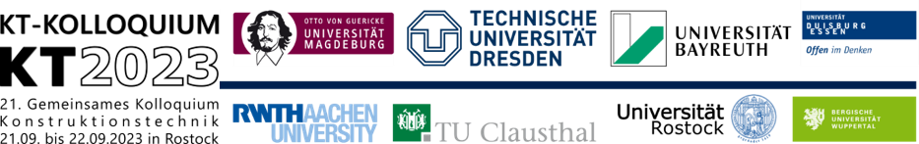
- University: | Your university or company |  | photo
- Titel: | Please enter title here
- Chair: | Institute or organisation
- Chair owner: | Prof. Dr.-Ing. Mustermann
- Position: | e.g. research assistant
- Research area: | Please briefly state the research area here
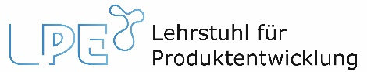 |  |  | 21.09. & 22.09.2023

